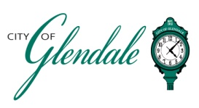
NOTICE OF PUBLIC MEETING
FEBRUARY 7, 2026 – 8:30 A.M.
BOARD OF ALDERMEN WORKSHOP

This meeting will be held at Sketch Studio Commons, located at 107 W. Pacific Ave., Webster Groves, MO 63110.

TENTATIVE AGENDA

- MEETING CALLED TO ORDER
- ROLL CALL
- STRATEGIC PRIORITIES/PLANNING WORKSHOP
  - Warm-up and Welcome
  - Values Discussion
  - Vision Discussion
  - Goal Development
  - Strategy Development

- ADJOURNMENT

_______________________
Frank Johnson
City Administrator Posted 3:00 P.M. February 5, 2026

